Diary 5: 30/10/2020

Playtesting

# Introduction:

This report takes a look at evaluations that are conducted during the creative process of a game or piece of software, reviewing how this can impact the final product and discusses whether these are helpful or not.

# Constructing evaluations:

Constructing a questionnaire takes time and thought to properly construct the correct set of questions that will allow you to maximise the potential of the feedback using a mixture of qualitative and quantitative questions.

Not only does this allow you to collect several forms of data but it also creates a more in-depth analysis of the feedback that the creator receives.

# Figure 1.1 & 1.2:

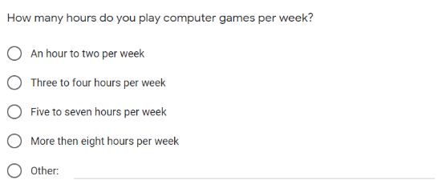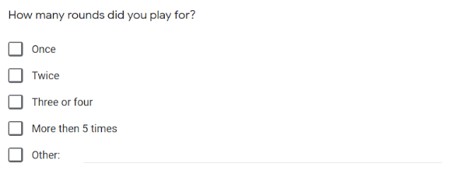

As show in figures 1.1 & 1.2, these are some of the ideal questions that the creator should look to use within his/her questionnaire using the other option as a qualitative and the numbered options as a quantitative option.

# Positives:

Using evaluation techniques such as questionnaires can greatly increase the chances of a piece of software or a game becoming successful. They allow the creator to present a focus group with an in progress model of their product and gain relative feedback in which they can use to enhance their products which is a major positive because they can add different features or they can adjust bugs within their product before their commercial release.

Another major positive is that questionnaires are usually anonymous which cancels out the possibility of fake reviews, allowing the person who fills out the questionnaires to be more truthful within their feedback, which means the data will be a far more accurate representation of the views of the focus group.

# Negatives:

Following on from that, if the questionnaires are not anonymous then the recipient can be far more compelled to follow the crowd and this can affect the results that the creator receives because it is not a true representation of the recipients thoughts on the product.

The questionnaires can also be fairly vague which can render the whole process pointless as the information can be rather thin in terms of the useable feedback.

Having spoke about focus groups, a focus group can actually be too big for the relevant product, meaning the data can be to large to gain a proper reading causing the creator of the product to have to single out certain opinions of the focus group, which again would not represent an accurate reading of the data.

# Future use:

Upon reviewing the use of the questionnaires that were created, a glaring flaw within the questions was that there was no rating system included within the questions (I.E what would you rate this game out of 10) which did not allow us to review our data properly. However, moving on from that the questions were still very eye opening, allowing us to gain a proper insight into the focus groups mind. Ideally taking this questionnaire to a larger audience to properly assess a wider range of views.